## Front End Engineering-II

Project Report

Semester-IV (Batch-2022)

Title of the Project

**SplitWise**



**Supervised By: Submitted By:**

Mr. SK Ansari Vrinda Puri: 2210992549

Yankit Kumar: 2210992552

Akshit Kansal: 2210990092

Swastik: 2210992432

**Department of Computer Science and Engineering**

## Chitkara University Institute of Engineering & Technology,

## Chitkara University, Punjab

**ABSTRACT:-**

Splitwise is a widely-used expense-sharing application that streamlines the process of managing shared expenses within groups. Developed using React, the app offers a user-friendly interface and a range of features to simplify financial coordination among friends, roommates, or colleagues. Users begin by signing up or logging in, accessing a personalized dashboard displaying summaries of current balances and recent transactions. Within the app, they can create groups, adding members and categorizing shared expenses. Each expense is meticulously tracked, with users inputting details such as amount, description, and participants. Utilizing React's dynamic capabilities, the app ensures equitable expense distribution among group members, either through manual input or automated algorithms. Notifications alert users to updates in their balances or new expenses. Additionally, the app facilitates debt settlement, allowing users to record payments or transfers between individuals, thus maintaining accurate financial records. Employing responsive design principles, the Splitwise React app delivers a seamless experience across various devices. Backend data management, facilitated by databases like Firebase Realtime Database, ensures efficient storage and retrieval of user information, group data, and transaction history. Through thorough testing and deployment on hosting platforms like Firebase Hosting, the Splitwise app guarantees reliability and accessibility to users, enhancing their ability to manage shared expenses effortlessly.

###### **TABLE OF CONTENTS**

|  |  |  |
| --- | --- | --- |
| serial no. | Section | Page No. |
| 1. | Introduction | *3-4* |
| 2. | Problem Statement | *5* |
| 3. | Technical Details | *6* |
| 4. | Key Features | *7* |
| 5. | Project Highlights | *8* |
| 6. | Project Advantages | *9* |
| 7. | *Results* | *9* |
| 8. | Conclusions | *10* |
| 9. | References | *10* |

**INTRODUCTION**

Splitwise is a widely-used expense-sharing application that streamlines the process of managing shared expenses within groups. Developed using React, the app offers a user-friendly interface and a range of features to simplify financial coordination among friends, roommates, or colleagues. Users begin by signing up or logging in, accessing a personalized dashboard displaying summaries of current balances and recent transactions.

**1. User Authentication: Start by creating a user authentication system where users can sign up, log in, and log out. You can use libraries like Firebase Authentication or implement your own server-side authentication.**

**2. Dashboard: Once authenticated, users are directed to their dashboard. The dashboard displays a summary of their current balances with other users and recent transactions.**

**3. Create Groups: Users can create groups for different sets of people they want to split expenses with. Each group can have multiple members.**

**4. Add Expenses: Within a group, users can add expenses and specify who paid for it and who owes how much. You'll need forms to input expense details like amount, description, and participants.**

**5. Expense Equivalence: Implement logic to ensure that expenses are split fairly among participants. You can allow users to specify custom splits or use algorithms to automatically calculate shares based on predefined rules.**

**For SplitWise:-**

1. **Notifications**: Notify users of new expenses, settlements, or any changes in their balances within the app.

2. **Settle Debts**: Users can settle debts by recording payments or transfers between each other. The app should update balances accordingly.

3. **Responsive Design**: Ensure your app is responsive, providing a seamless experience across different devices and screen sizes.

4. **Data Management**: Use a database (like Firebase Realtime Database or Firestore) to store user data, group information, expenses, and transaction history.

5. **Testing and Deployment**: Test your app thoroughly to ensure it works as expected and deploy it to a hosting platform like Firebase Hosting or Netlify.

**PROBLEM STATEMENT**

In today's interconnected world, people often share expenses with friends, family, or colleagues for various activities such as group outings, vacations, household bills, or shared living expenses. However, managing these shared expenses efficiently can become a daunting task, leading to confusion, misunderstandings, and even strained relationships.

Existing methods of splitting expenses, such as manual calculations or spreadsheets, are time-consuming, error-prone, and lack transparency. Participants may forget who paid for what, how much they owe or are owed, and resolving these discrepancies can be challenging.

To address these issues, we propose the development of a digital solution called Splitwise. Splitwise is an intuitive and user-friendly expense-sharing application designed to streamline the process of managing shared expenses among groups of people.

**1.Technologies Used**

**HTML:**

The HTML document is structured using standard HTML tags.

The document has two <head> sections. The first section includes meta tags for character set, compatibility, and viewport settings. It also includes a title tag and a link tag to an external CSS file.

The CSS styles are defined within <style> tags in the <head> section.

The body of the document contains two main sections: the sign-up form and the task Management section.

**CSS:**

The CSS styles are defined within <style> tags in the <head> section.

The * selector sets the font family to 'poppins' and the text colour to black for all elements in the document.

The body background image is set using the background-image property.

**JavaScript:**

The JavaScript code snippet provided seems to be incomplete as it is missing the opening and closing <script> tags.

The code adds an event listener to the form's submit event using the add Event Listener method.

When the form is submitted, it prevents the default form submission behaviour using event.preventDefault().

The structure of the website has many different features provided for better communication and easy interaction. Some of them are listed below: -

**REACT:**

React is a JavaScript library known for its component-based architecture and virtual DOM. It offers JSX syntax for writing UI components, enabling a more intuitive development experience.

With a unidirectional data flow, React ensures predictable state management. Its declarative approach simplifies UI development, allowing developers to focus on describing the interface's desired state rather than the step-by-step manipulation of the DOM.

This results in efficient, scalable, and dynamic web applications.Top of Form

**KEY FEATURES**

The structure of the website has many different features provided for better communication and easy interaction. Some of them are listed below:

**Mobile Responsiveness-**A mobile-responsive feature of our travel agency website ensures:

* Increased visibility and higher ranks on search engines
* A better user experience
* Increased conversion rates

**SplitWise-**

Splitwise is a handy tool for managing shared expenses among friends, roommates, or colleagues.

Whether you're splitting bills for rent, groceries, utilities, or a group trip, Splitwise simplifies the process by keeping track of who owes what to whom.

**RESULTS OF PROJECT**

* **Home page.**



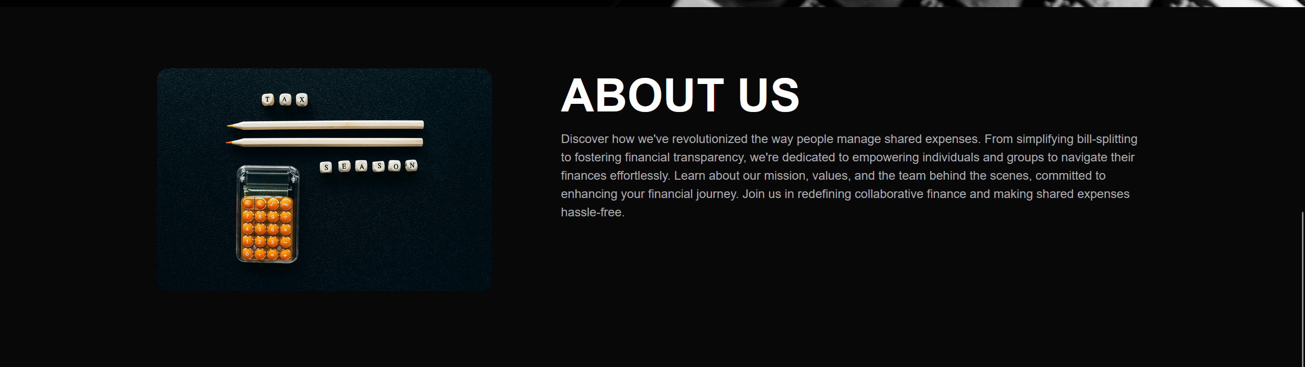

* **Features**

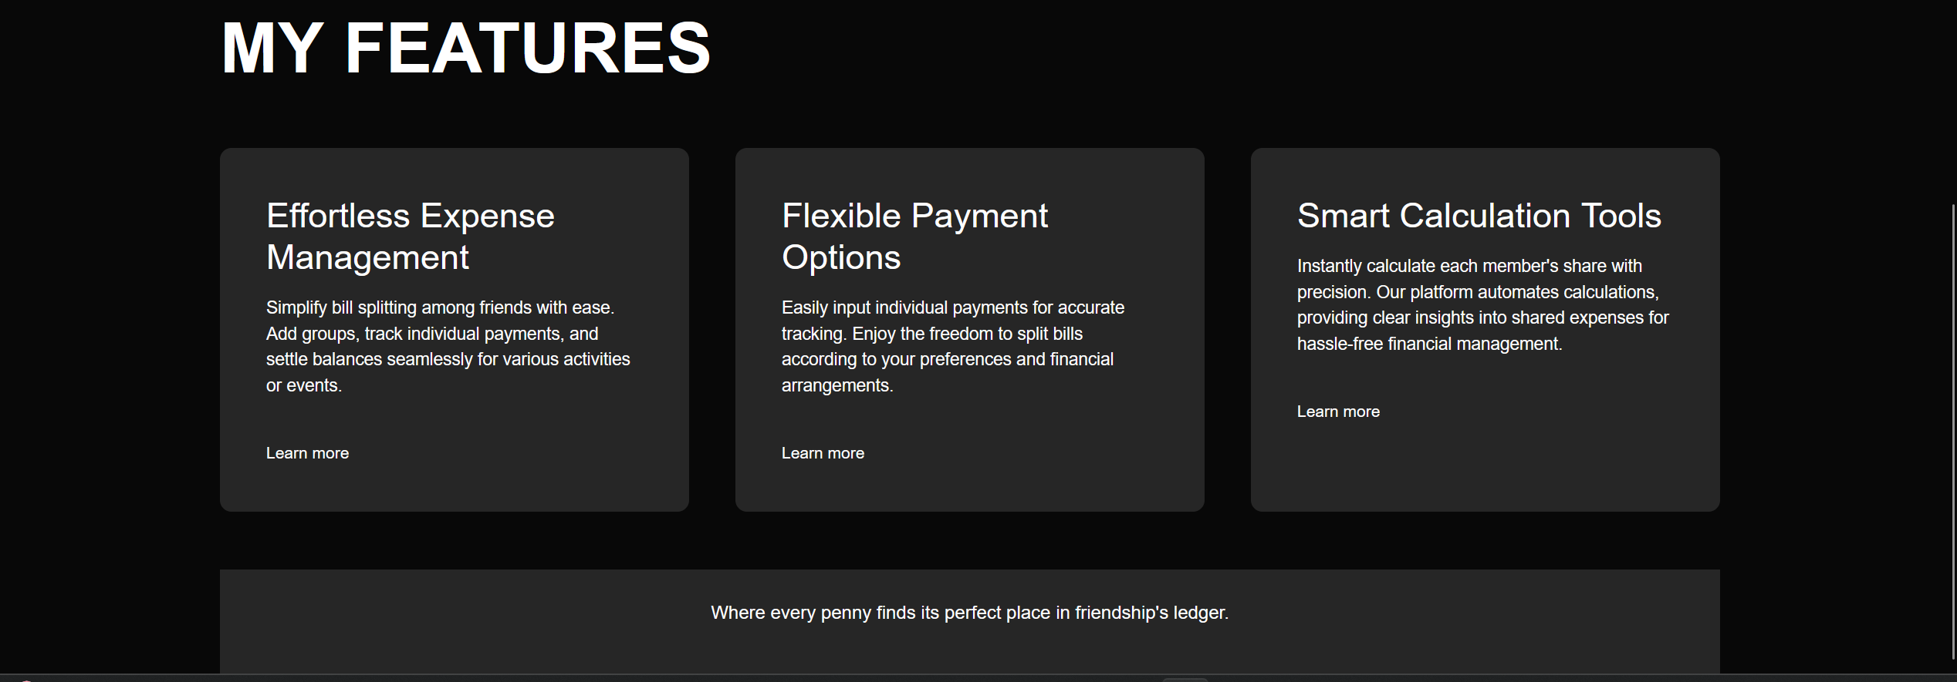

**Services**

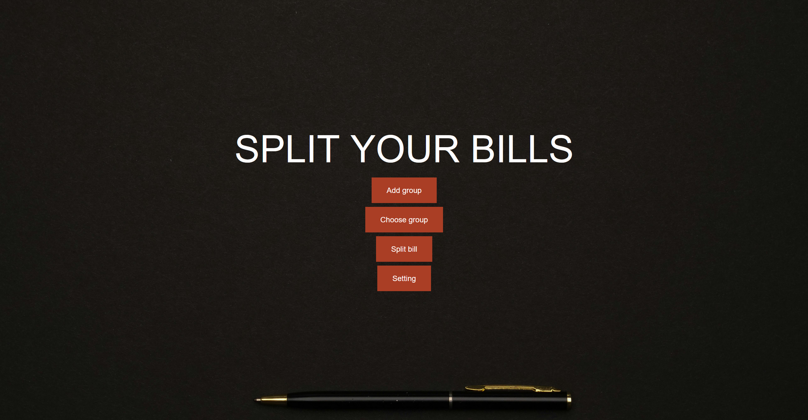

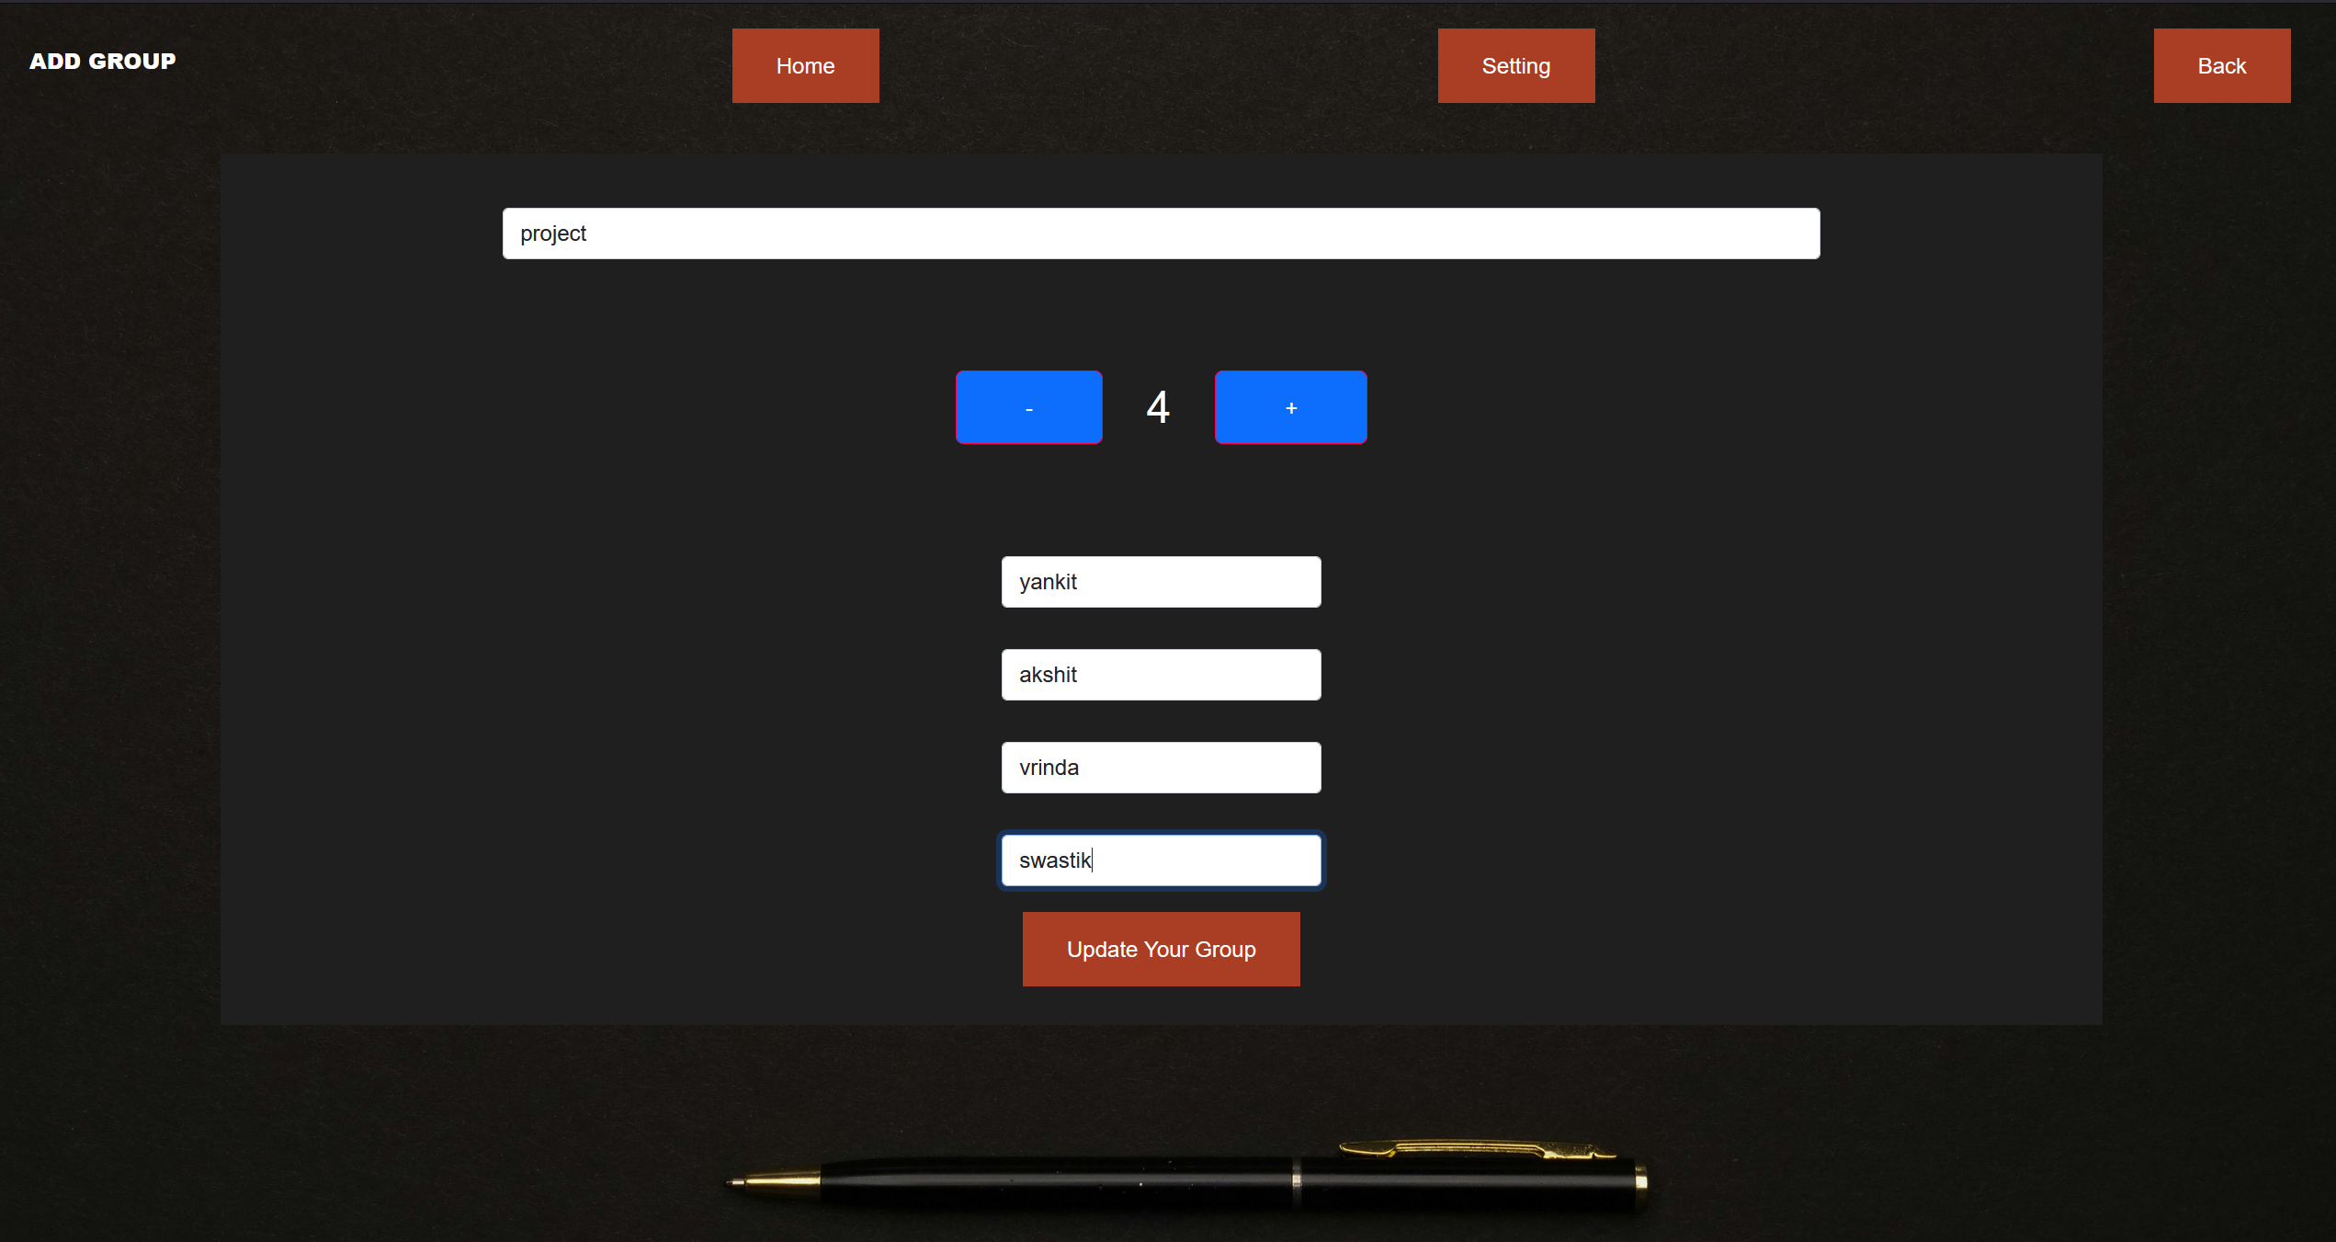

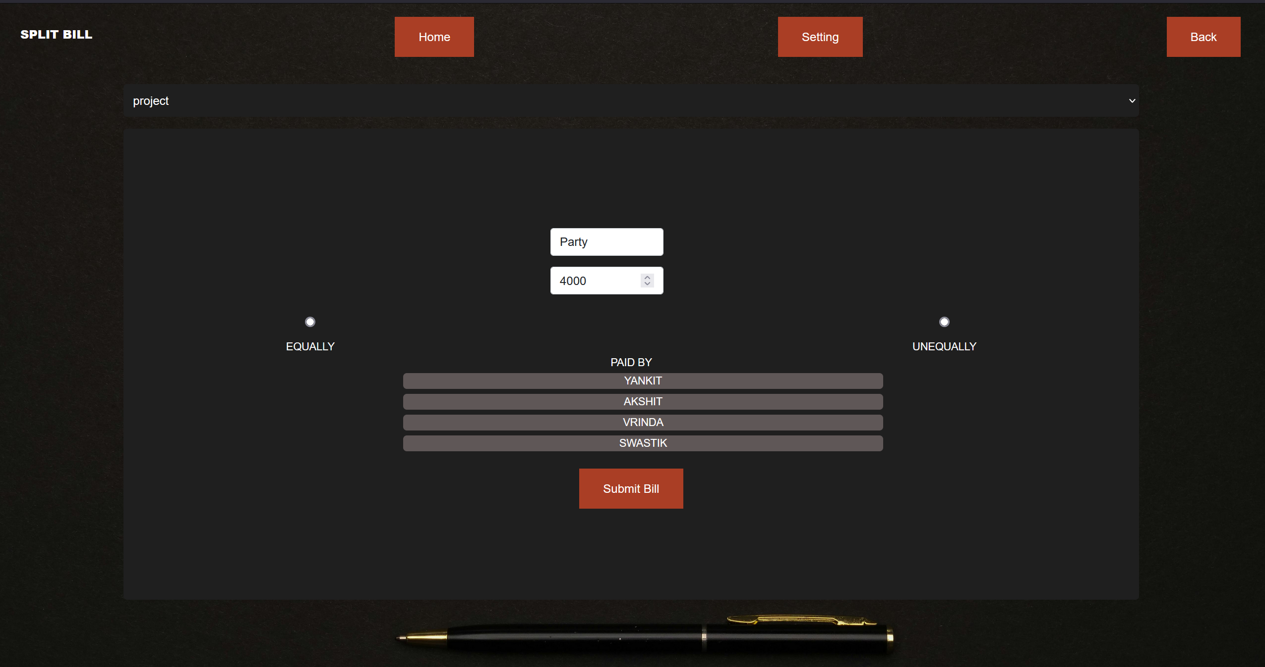

**CONCLUSION**

Building a Splitwise-like application with React empowers developers to create a feature-rich platform that simplifies expense tracking and sharing among users. React's component-based architecture encourages modular development, facilitating the creation of reusable components for managing expenses, groups, and user interactions. By leveraging React's state management capabilities, developers can dynamically update the UI in response to user actions, ensuring a fluid and responsive user experience. React's routing capabilities enable the creation of a multi-page application structure, allowing users to seamlessly navigate between different sections of the application.

Integrating with backend services enables developers to store and retrieve user data securely, ensuring data integrity and privacy. Implementing user authentication mechanisms ensures that only authorized users can access sensitive information and perform actions such as adding expenses or joining groups. Real-time updates using technologies like WebSockets enhance collaboration by instantly reflecting changes made by other users, providing a synchronized experience across devices.

Furthermore, React's extensive ecosystem of libraries and tools, such as Redux for state management, React Router for navigation, and Material-UI for UI design, accelerates development and enhances the application's functionality and aesthetics. Comprehensive testing using tools like Jest and React Testing Library ensures the reliability and stability of the application, reducing the likelihood of bugs and errors. Finally, deploying the application to a reliable hosting platform ensures accessibility to users worldwide, offering a seamless and accessible experience for managing expenses collaboratively. In conclusion, building a Splitwise-like application with React empowers developers to create a sophisticated and user-friendly platform for efficient expense management and sharing.

**REFERENCES**

* <https://github.com/login>
* <https://www.w3schools.com>
* <https://en.wikipedia.org/wiki/CSS>
* <https://www.codewithharry.com/videos/css-in-one-video>
* <https://www.codewithharry.com/videos/html-tutorial-for-beginners>
* <https://chat.openai.com/>